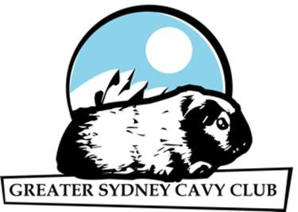
GREATER SYDNEY CAVY CLUB OFFICIAL ENTRY FORM
Revised 10/2022
Show: STANDARD BREEDS & YOUNG STOCK SHOW Date: 20/11/2022

EAR |  | BREED | DATE | SECTION | CLASSES |  |  | Exhibitor Name
 | CAVY NAME |  |  | (A) Boar
TAG |  | and | of | (B) Sow | (Please number clearly)
 |  | COLOUR | BIRTH | (I) Inter |  | Young | Jun
(office use) | Include any Championship Status | (not required for Coarse  Coat |  | (C) Junior | Standard | Stock | Ex | (if more than
 | ie Ch = Champion, Dbl Ch = Double Champion | or Longhaired Breeds) |  | (D) Baby | Breed  Class | Show | (tick) | one exhibitor)

Standard Breed Show Entry fee: $10.00 Plus entries @ $2.00 each = $

Young Stock Show Entry fee: $10.00 Plus entries @ $2.00 each = $
TOTAL Entry fee = $
Exhibitor Name/s: Stud: Address: Email: Phone: We, the exhibitors, agree to abide by the constitution and show rules set down by the Greater Sydney Cavy Club Inc, and are members of an ANCC affiliated cavy club. Signed: I am a member of Club/s:

PLEASE TRY NOT TO PAY ON THE DAY or: GSCC Inc. Shows: CHEQUE: Payable to GREATER SYDNEY CAVY CLUB INC. (GSCC Inc.).
WE PREFER THAT YOU PAY VIA DIRECT DEPOSIT: BSB 012-372, Account No: 407 562 806, ANZ Bank. If direct deposit is used, a copy of the receipt must accompany entry.

