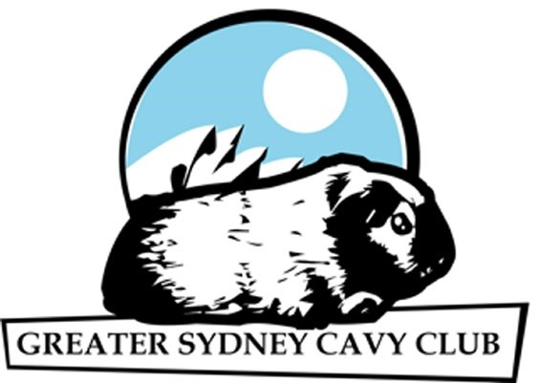
GREATER SYDNEY CAVY CLUB OFFICIAL ENTRY FORM
Revised 2021
Show: _______________________________ Date: _________________

EAR TAG  (  )  office use only | CAVY NAME | BREED/ COLOUR | DOB/  SEX | SECTION  - Boar;  - Sow;  (I) Inter;  - Junior;  - Baby | CLASSES  (Please print Class numbers clearly) |  |  | Exhibitor Name  (  )  if more than 1 exhibit
 |  |  |  |  | General  Class | Members  Pet | Junior Ex (tick)

Entry fee: $10.00 Plus ________ entries @ $2.00 each = $ _____
TOTAL Entry fee = $ _____
Exhibitor Name/s: ________________________________ Stud: _________________________________
Address: _______________________________________________________________________________ Email: __________________________________________ Phone: ________________________________
We, the exhibitors, agree to abide by the constitution and show rules set down by the Greater Sydney Cavy Club Inc, and are members of an ANCC affiliated cavy club. Signed: ___________________________________________________________________________
I am a member of Club/s: ______________________________________________________________________________________
PLEASE TRY NOT TO PAY ON THE DAY or: GSCC Inc. Shows: CHEQUE: Payable to GREATER SYDNEY CAVY CLUB INC. (GSCC Inc.).
WE PREFER THAT YOU PAY VIA DIRECT DEPOSIT: BSB 012-372, Account No: 407 562 806, ANZ Bank. If direct deposit is used, a copy of the receipt must accompany entry.

